ASSIGNMENT-03
NAME:-P.VARSHITHA
ENROLLMENT NUMBER:-2503A52398
BATCH:-14
Question 1: Zero-Shot Prompting (Palindrome Number Program)
Write a zero-shot prompt (without providing any examples) to generate a Python function that checks whether a given number is a palindrome.
Task:
● Record the AI-generated code.
● Test the code with multiple inputs.
● Identify any logical errors or missing edge-case handling.
INPUT:-
num = int(input("Enter a number: "))
if str(num) == str(num)[::-1]:
print("Palindrome Number")
else:
print("Not a Palindrome Number")
OUTPUT:-
Question 2: One-Shot Prompting (Factorial Calculation) Write a one-shot prompt by providing one input-output example and ask the AI to generate a Python function to compute the factorial of a given number.
Task:
● Compare the generated code with a zero-shot solution.
● Examine improvements in clarity and correctness.
INPUT:-
n = int(input("Enter a number: "))
factorial = 1
for i in range(1, n + 1):
factorial *= i
print("Factorial:", factorial)
OUTPUT:-
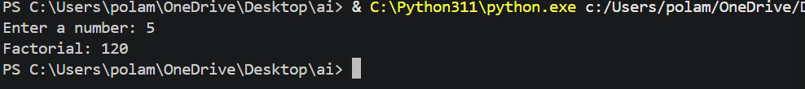
Question 3: Few-Shot Prompting (Armstrong Number Check) Write a few-shot prompt by providing multiple input-output examples to guide the AI in generating a Python function to check whether a given number is an Armstrong number.
Task:
● Analyze how multiple examples influence code structure and accuracy.
● Test the function with boundary values and invalid inputs.
Input:-
num = int(input("Enter a number: "))
digits = str(num)
power = len(digits)
total = sum(int(digit) ** power for digit in digits)
if total == num:
print("Armstrong Number")
else:
print("Not an Armstrong Number")
OUTPUT:-
Question 4: Context-Managed Prompting (Optimized Number Classification) Design a context-managed prompt with clear instructions and constraints to generate an optimized Python program that classifies a number as prime, composite, or neither. Task:
● Ensure proper input validation.
● Optimize the logic for efficiency.
● Compare the output with earlier prompting strategies.
INPUT:-
num = int(input("Enter a number: "))
if num <= 1:
print("Neither Prime nor Composite")
else:
is_prime = True
for i in range(2, int(num ** 0.5) + 1):
if num % i == 0:
is_prime = False
break
if is_prime:
print("Prime Number")
else:
print("Composite Number")
OUTPUT:-
Question 5: Zero-Shot Prompting (Perfect Number Check) Write a zero-shot prompt (without providing any examples) to generate a Python function that checks whether a given number is a perfect number.
Task:
● Record the AI-generated code.
● Test the program with multiple inputs.
● Identify any missing conditions or inefficiencies in the logic.
INPUT:-
num = int(input("Enter a number: "))
sum_of_divisors = 0
for i in range(1, num):
if num % i == 0:
sum_of_divisors += i
if sum_of_divisors == num:
print("Perfect Number")
else:
print("Not a Perfect Number")
OUTPUT:-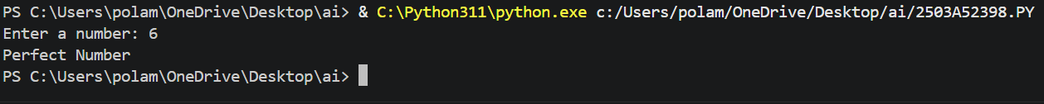
Question 6: Few-Shot Prompting (Even or Odd Classification with Validation) Write a few-shot prompt by providing multiple input-output examples to guide the AI in generating a Python program that determines whether a given number is even or odd, including proper input validation.
Task:
● Analyze how examples improve input handling and output clarity.
● Test the program with negative numbers and non-integer inputs.
INPUT:-
try:
num = int(input("Enter an integer: "))
if num % 2 == 0:
print("Even")
else:
print("Odd")
except ValueError:
print("Invalid input. Please enter an integer.")
OUTPUT:-

